Sonar_Parth_Narendra_D6_56
31/08/26

LAB_03
Aim: To design and represent an Entity Relationship (ER) diagram for a real-world database system using the draw.io tool by identifying entities, attributes, keys, relationships and cardinalities.
Integrated University Research Management System:
Design a complete ER model for a University Research Management System. The system should maintain information about Researchers, Departments, Research Projects, Students, Publications, and Project Dependents/Assistants.

A Researcher has a unique Researcher_ID, Name, Date_of_Birth, Email, multiple Phone Numbers, and Address. Address consists of Street, City, State, and PIN Code. Age is calculated from Date_of_Birth.

Each researcher belongs to a Department. A department has Department_ID, Department_Name, and Location.

A researcher can work on multiple Research Projects. Each project has Project_ID, Project_Title, Start_Date, End_Date, Budget, and multiple Keywords. A project may involve multiple researchers.

A researcher can have multiple Students working under them. Each student has Student_ID, Name, Email, and Date_of_Birth.

Each research project can produce multiple Publications. A publication has Publication_ID, Title, Publication_Date, DOI, and Publisher.

A project may also have Project Assistants. An assistant is identified only within the context of its project and has Assistant_Name, Role, and Joining_Date. The same assistant name may occur in different projects.
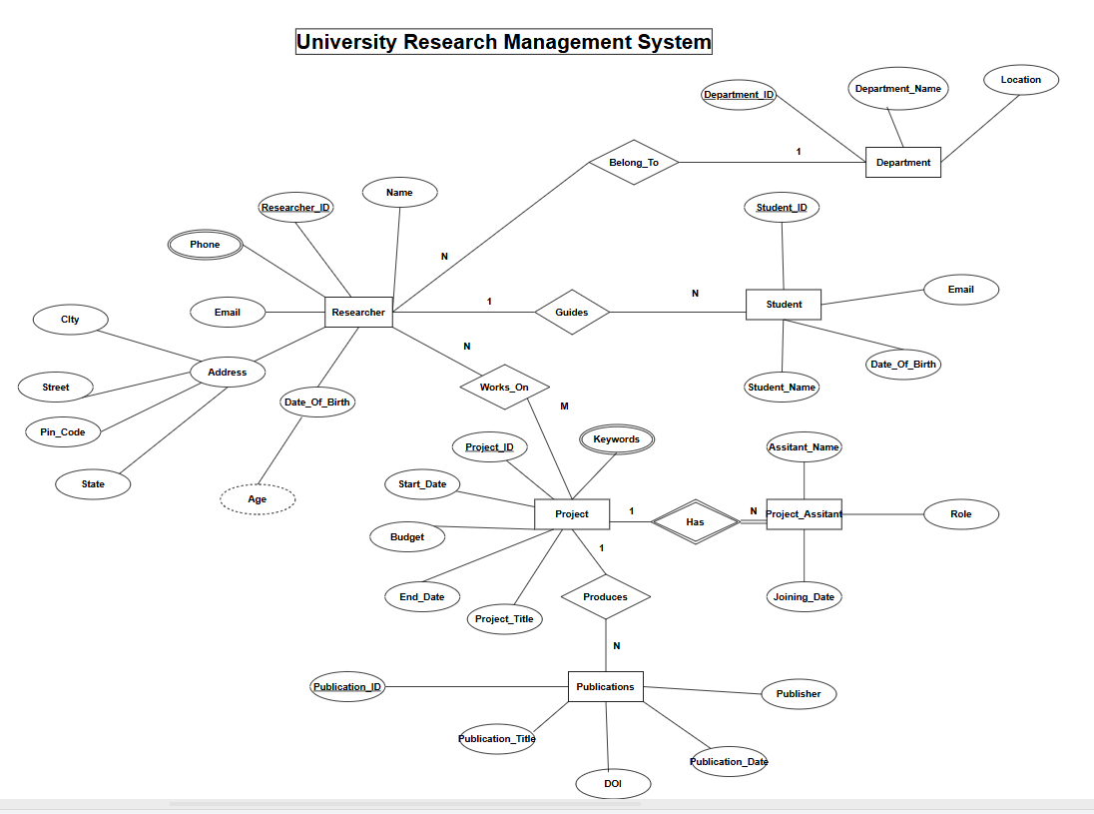

Tasks:
1. Identify all entity types and entity sets.
There are two types of entities: strong entity and weak entity. Strong entities are Researcher, Department, Project, Student and Publication. Project Assistant is a weak entity.
2. Identify strong and weak entity sets.
Strong Entity Sets: Researcher, Department, Project, Student, Publication.
Weak Entity Set: Project Assistant.
3. Identify the owner entity and partial key of the weak entity.
The owner entity is Project. The partial key of Project Assistant is Assistant_Name. Its complete identification is Project_ID + Assistant_Name.
4. Identify simple attributes.
Researcher_ID, Name, Date_of_Birth, Email, Phone Number, Street, City, State, PIN Code, Department_ID, Department_Name, Location, Project_ID, Project_Title, Start_Date, End_Date, Budget, Keywords, Student_ID, Student_Name, Student Email, Student Date_of_Birth, Publication_ID, Title, Publication_Date, DOI, Publisher, Assistant_Name, Role and Joining_Date.
5. Identify composite attributes.
Address is a composite attribute. It consists of Street, City, State and PIN Code.
6. Identify single-valued attributes.
Researcher_ID, Name, Date_of_Birth, Email, Address, Department_ID, Department_Name, Location, Project_ID, Project_Title, Start_Date, End_Date, Budget, Student_ID, Student_Name, Student Email, Student Date_of_Birth, Publication_ID, Title, Publication_Date, DOI, Publisher, Assistant_Name, Role and Joining_Date.
7. Identify multi-valued attributes.
Phone Number and Keywords are multi-valued attributes. A researcher can have multiple phone numbers and a project can have multiple keywords.
8. Identify stored attributes.
All attributes except Age are stored attributes. Age is calculated from Date_of_Birth.
9. Identify derived attributes.
Age is a derived attribute because it is calculated from Date_of_Birth.
10. Identify key attributes.
Researcher_ID, Department_ID, Project_ID, Student_ID and Publication_ID are primary key attributes. Assistant_Name is the partial key of Project Assistant.
11. Identify candidate keys and select appropriate primary keys.
Researcher: Researcher_ID (PK)
Department: Department_ID (PK)
Project: Project_ID (PK)
Student: Student_ID (PK)
Publication: Publication_ID (PK)
Project Assistant: Project_ID + Assistant_Name (composite primary key).
12. Identify at least one composite key.
Project Assistant has the composite key (Project_ID, Assistant_Name). The Works_On relation also has the composite key (Researcher_ID, Project_ID).
13. Identify appropriate foreign keys after converting the ER model into relations.
Researcher.Department_ID → Department(Department_ID)
Student.Researcher_ID → Researcher(Researcher_ID)
Publication.Project_ID → Project(Project_ID)
Project_Assistant.Project_ID → Project(Project_ID)
Works_On.Researcher_ID → Researcher(Researcher_ID)
Works_On.Project_ID → Project(Project_ID).
14. Identify all major relationships between the entities.
Belongs_To: Researcher–Department (N:1)
Works_On: Researcher–Project (M:N)
Guides: Researcher–Student (1:N)
Produces: Project–Publication (1:N)
Has: Project–Project Assistant (1:N).
15. Draw the complete ER diagram using standard ER notation.
The complete ER diagram is prepared in draw.io using standard ER notation. It includes entities, relationships, keys, cardinalities, composite, multi-valued, derived and weak-entity notation.
16. Prepare a table showing each attribute and its attribute type and key status.
Entity | Attribute | Attribute Type | Key Status
Researcher | Researcher_ID | Simple, Single-valued | Primary Key
Researcher | Name | Simple, Single-valued | Non-key
Researcher | Date_of_Birth | Simple, Stored | Non-key
Researcher | Age | Derived | Non-key
Researcher | Email | Simple, Single-valued | Non-key
Researcher | Phone Number | Multi-valued | Non-key
Researcher | Address | Composite | Non-key
Address | Street, City, State, PIN Code | Simple | Non-key
Department | Department_ID | Simple, Single-valued | Primary Key
Department | Department_Name | Simple, Single-valued | Non-key
Department | Location | Simple, Single-valued | Non-key
Project | Project_ID | Simple, Single-valued | Primary Key
Project | Project_Title | Simple, Single-valued | Non-key
Project | Start_Date | Simple, Single-valued | Non-key
Project | End_Date | Simple, Single-valued | Non-key
Project | Budget | Simple, Single-valued | Non-key
Project | Keywords | Multi-valued | Non-key
Student | Student_ID | Simple, Single-valued | Primary Key
Student | Student_Name | Simple, Single-valued | Non-key
Student | Email | Simple, Single-valued | Non-key
Student | Date_of_Birth | Simple, Single-valued | Non-key
Publication | Publication_ID | Simple, Single-valued | Primary Key
Publication | Title | Simple, Single-valued | Non-key
Publication | Publication_Date | Simple, Single-valued | Non-key
Publication | DOI | Simple, Single-valued | Non-key
Publication | Publisher | Simple, Single-valued | Non-key
Project Assistant | Assistant_Name | Simple | Partial Key
Project Assistant | Role | Simple, Single-valued | Non-key
Project Assistant | Joining_Date | Simple, Single-valued | Non-key

